Literature Review

Haridas, G and George, D. S proposed an Area efficient Low Power FIR filter by implementing a spanning tree based modified Booth multiplier and a modified spanning tree adder. It is known that the operation of FIR filter could be described as $y\left[n\right]= \sum_{k=0}^{N-1}{h\left[k\right]*x[n-k]}$. (x[n], y[n] and h[n] represents data input, filtering output and a coefficient, N is the filter order).
The structure of this proposed filter design is shown below in Fig.ref1.1. To be more detailed, the spanning tree based modified booth multiplier does the concurrent multiplications of delayed signals and the coefficients. Then the modified spanning adder is used to do the adding of the products. The final addition is performed by the spanning tree parallel prefix adder.
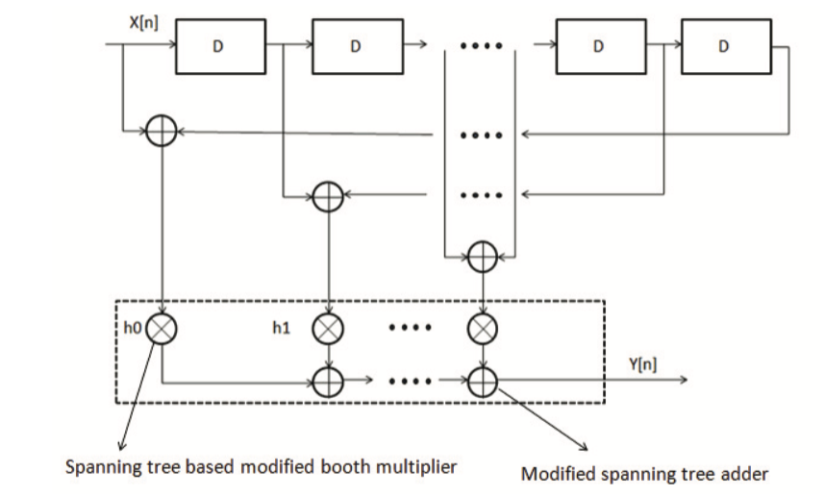
Fig. ref1.1 Architecture of proposed FIR filter
Firstly, The modified booth multiplier depends on the Booth encoding algorithm ton reduce the number of partial produces, which allows the multiplier to deal with 3 bits at a time during recoding. The modified booth algorithm is shown in Fig. ref1.2.
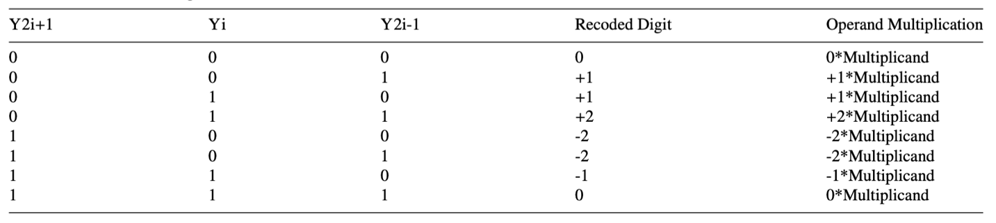
Fig. ref1.2 Modified booth algorithm
And Fig. ref1.3 also shows the architecture of the proposed modified booth multiplier. Modified booth algorithm which encodes the multiplier bits, followed by partial product generator which produces partial products by operating on multiplicand and reduce number of partial products. Then the partial products are added using Wallace tree. And finally the output of Wallace tree are added using modified spanning tree parallel prefix adder and adder gives the final product.
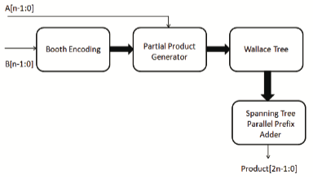
Fig. ref1.3 Architecture of modified booth multiplier
The proposed modified spanning tree adder consists of a 4-bit ripple carry adder and carry predictor logic. The carry predictor can predict the carry input to the 4-bit ripple carry adder, thus could save power consumption. And the architecture of modified tree adder and the carry predictor are shown below in Fig. ref1.4.
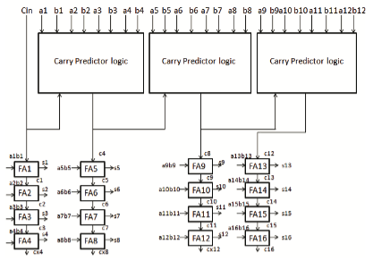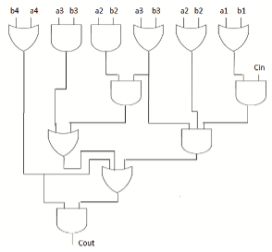
Fig. ref1.4 (a) Tree adder. (b) Predictor logic

M. Jayashree from RMK Engineering college proposed a scheme that replace the traditional ripple carry adder and Wallace tree multiplier with Reduced square root carry select adder and Bi-recoder multiplier, which could overcome the drawbacks from area & delay. The architecture of the 16-bit SQRT CSLA is shown below in Fig. ref2.1.
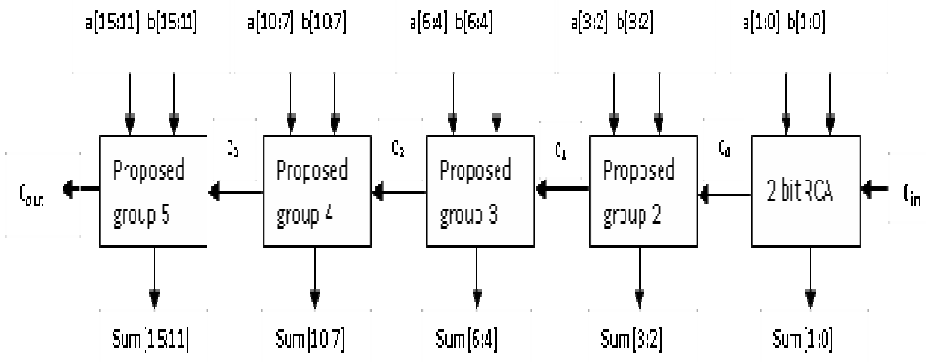
Fig. ref2.1 Proposed SQRT Carry Select Adder
The calculation path is divided into several groups. Each group consists of RCA, BEC and multiplexer. And carry-in is propagated through the multiplexer from the previous group. And then the sum output of each group is generated using multiplexors. The design of the group structure is shown below in Fig. ref2. 2
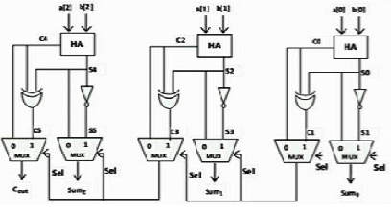
Fig. ref2. 2 The architecture of the group element
The Bi-recoder multiplier make use of multiplexer to pass the partial product to the output using the combine of two bits of the multiplicand. An N-bit multiplier need to implement N multiplexers to deal with the partial product. The select signal is “00”, then the multiplexer just pass “0” to the output; If the signal is “01”, the multiplexer pass the multiplicand value to the output; If the signal is “10”, the multiplexer pass the 1-bit left shifted multiplicand to the output. And if the signal is “11”, then the multiplexer pass the addition result of the 1-bit left shifted multiplicand and the multiplicand to the result. The architecture of the Bi-Recoder Multiplier is shown below in Fig. ref2. 3 as an example.
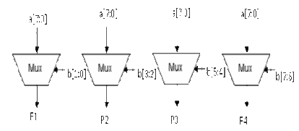
Fig. ref2. 3

